Họ và tên: ……Trần Gia Nguyên Phong…. MSSV: …22002575…………….
LAB 12 - PROCESSOR ARCHITECTURE

Practice Problem 4.1
Determine the byte encoding of the Y86 instruction sequence that follows. The line “.pos 0x100” indicates that the starting address of the object code should be 0x100.

.pos 0x100 # Start code at address 0x100
irmovl $15,%ebx # Load 15 into %ebx
0x100 (30F30F000000)
rrmovl %ebx,%ecx # Copy 15 to %ecx
0x106 (2031) 15=0x0000000F
loop: # loop:
0x108
rmmovl %ecx,-3(%ebx) # Save %ecx at address 15-3=12
0x108 (4013fdffffff) -3=0xfffffffd
addl %ebx,%ecx # Increment %ecx by 15
0x10e (6031)
jmp loop # Goto loop
0x110 (70) 0x108=0x00000108 => 08010000

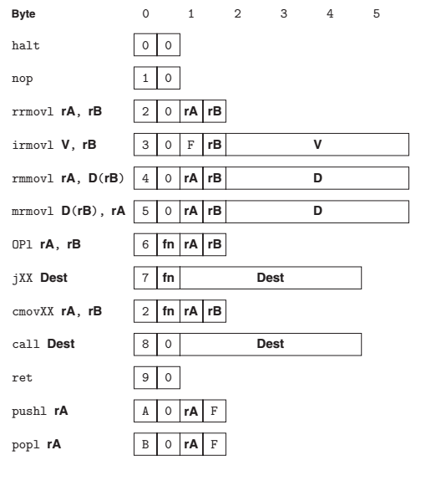
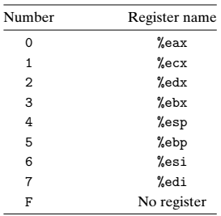
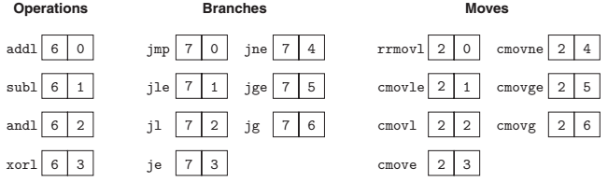

Practice Problem 4.2
For each byte sequence listed, determine the Y86 instruction sequence it encodes.
If there is some invalid byte in the sequence, show the instruction sequence up to that point and indicate where the invalid value occurs. For each sequence, we show the starting
address, then a colon, and then the byte sequence.

A. 0x100:30f3fcffffff40630008000000
0x100: 30f3fcffffff
0x106: 406300080000
0x10C: 00
Irmovl $ -4,%ebx fcffffff => fffffffc => -4
Rmmovl %esi, (%ebx) 00080000 => 00000800 => 0x800
halt
B. 0x200:a06f80080200000030f30a00000090
0x200: a06f
0x202: 8008020000
0x207: 00
0x208: 30f30a000000
0x20e: 90
Push %esi
Call proc
Halt
Proc:
Irmoy $10, %ebx 0a000000 => 0000000a = 0xA = 10
ret
C. 0x300:50540700000010f0b01f
0x300: 505407000000
0x306:10
0x307:f0
0x308:b01f
Mrmovl 7(%esp),%ebp
Nop
# byte 0xf0 invalid instruction code
Popl %ecx
D. 0x400:6113730004000000
0x400:
0x400: 6113
0x402: 7300040000
0x407: 00
Loop:
Subl %ecx, %ebx
Je loop jum dest:000400000 => 00000400 => 0x400
halt
E. 0x500:6362a0f0
0x500: 06362a0f0
0x500:6362
0x502:a0
0x503:f0
Xorl %esi,%edx
# push instruction code
# byte 0xf0: invalid register specifier byte
Practice Problem 4.26
Suppose we analyze the combinational logic of Figure 4.32 and determine that it can be separated into a sequence of six blocks, named A to F, having delays of 80, 30, 60, 50, 70, and 10 ps, respectively, illustrated as follows:

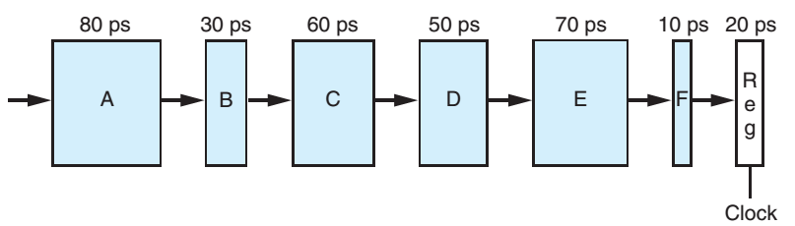
We can create pipelined versions of this design by inserting pipeline registers between pairs of these blocks. Different combinations of pipeline depth (how many stages) and maximum throughput arise, depending on where we insert the pipeline registers. Assume that a pipeline register has a delay of 20 ps.
- Inserting a single register gives a two-stage pipeline. Where should the register be inserted to maximize throughput? What would be the throughput and latency?
80 30 60 20
A B C REG
=> 190ps
50 70 10 20
D E F REG
=> 150ps
=> through put = 5,26 GOPS
=> latency = 190 x 2 = 380ps
- Where should two registers be inserted to maximize the throughput of a three-stage pipeline? What would be the throughput and latency?
There stage pipeline
80 30 20 60 50 20 70 10 20
A B REG C D REG E F REG
130 | 130 | 100
=> Through put = 7,69 GOPS
=> Latency = 130 x 3 = 390PS
- Where should three registers be inserted to maximize the throughput of a four-stage pipeline? What would be the throughput and latency?
80 20 30 60 20 50 20 70 10 20
A REG B C REG D REG E F REG
100ps | 110ps |70ps | 100ps
- Through put = 9.09 GOPS
- Latency = 110 x 4 = 440 PS
- What is the minimum number of stages that would yield a design with the maximum achievable throughput? Describe this design, its throughput, and its latency.
80 20 30 20 60 20 50 20 70 10 20
A REG B REG C REG D REG E F REG
100PS| 50PS | 80PS | 70PS | 100PS
- Through put = 10.0 GOPS
- Latency = 100 x 5 = 500 PS

Through put = (1/cycle time) x ((1000ps x 10^-12)/(1 nanosecond x 10^-9))
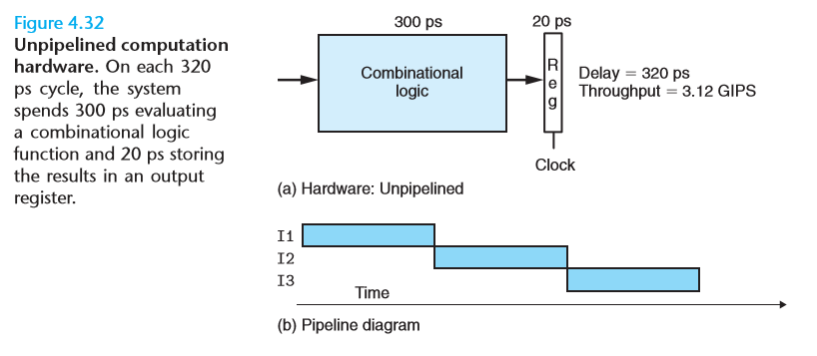

Practice Problem 4.27
Suppose we could take the system of Figure 4.32 and divide it into an arbitrary number of pipeline stages k, each having a delay of 300/k, and with each pipeline register having a delay of 20 ps.
A. What would be the latency and the throughput of the system, as functions of k?
B. What would be the ultimate limit on the throughput?

